**Install Data Analysis Add-in for Excel on Mac**

* If you prefer video instructions, go to  <https://www.youtube.com/watch?v=mtmrAXwLcuU>
* Open **Excel** for **Mac**. You can this link and follow the instruction to download it using your school email. <https://www.fordham.edu/info/25689/microsoft_office_365>
* Go to the **Tools** menu, select "**Add-ins**"

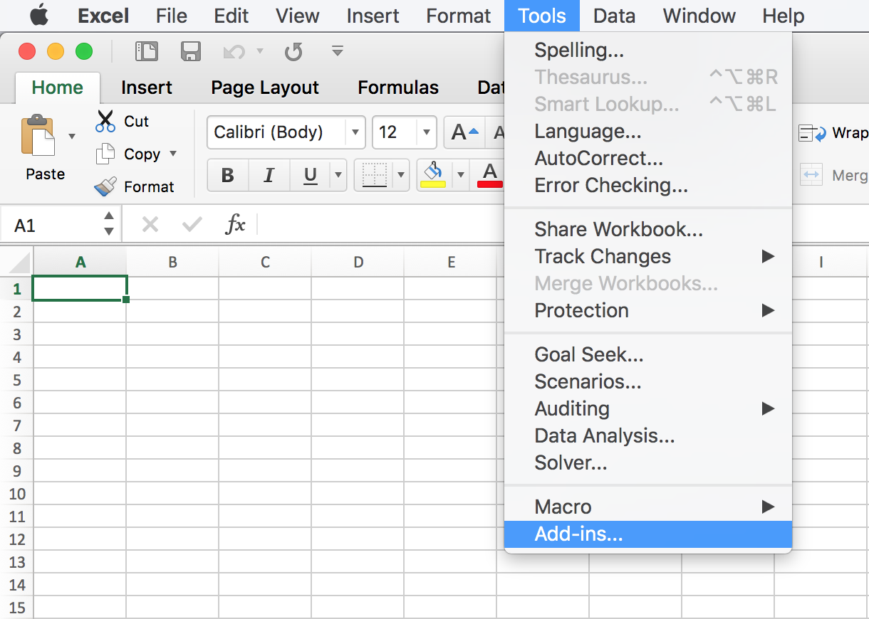

* Check "**Solver Add-in**" and "**Analysis ToolPak**" then click OK.

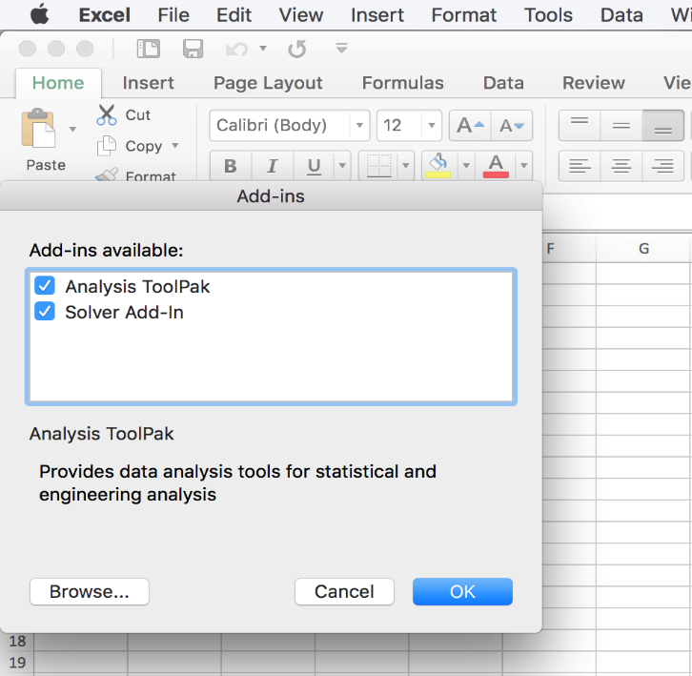

* Under the "**Data**" tab, and you can choose "Solver" or "Data Analysis".

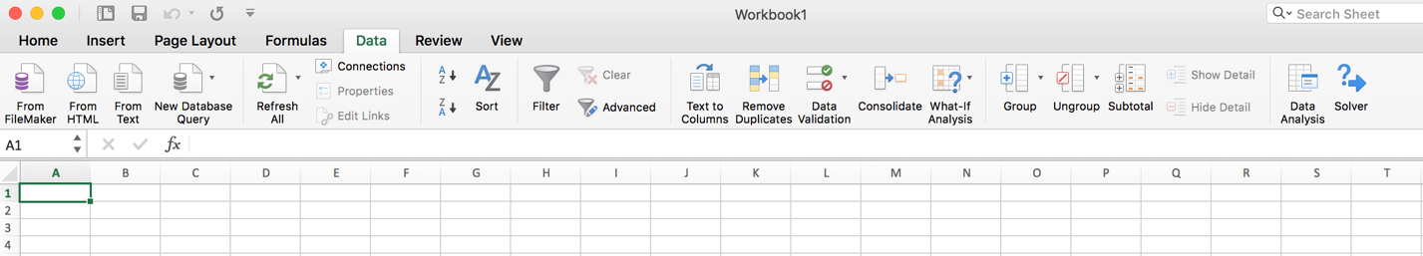

**Enabling Data Analysis ToolPak in Excel on Windows**

**Data Analysis Toolpak** is an **add-in** in Excel and it is already there in Excel. All you need to do is enable it. Here is how.

**File 🡪 Options 🡪 Addins 🡪**

At the bottom of that screen, you should see



Make sure **Excel Add-ins** is selected**.** Press **Go**

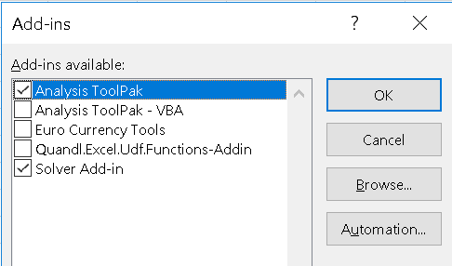

If **Analysis TooPak** is NOT selected, make sure you select it, and Press **OK.**

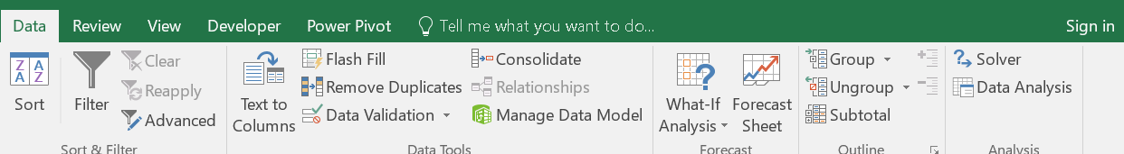The **Analysis ToolPak** should be ready to use. Go to the **Data** tab in excel, and you should see it on the right